MENG 4010 – INDUSTRIAL NETWORKING
Lab 09 Report – Introduction to Cisco Packet Tracer

Item | Details
Student | Michael McCorkell (N01500049)
Course | MENG 4010 – Industrial Networking
Lab Date | September 10, 2026
Software | Cisco Packet Tracer 8.2.2
Devices simulated | 1 Router (Cisco 2911); 3 Switches (Cisco 2960); 6 PCs (3 HR, 3 IT); 1 File Server; 1 Network Printer

Instructor’s Confirmation
The course instructor’s signature below verifies completion of the lab demonstration.

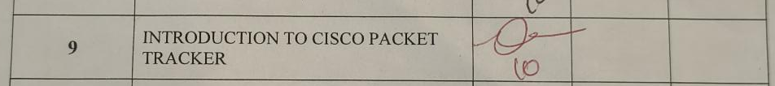
1. Objectives
By the end of this lab, you will be able to:
- Open and navigate Cisco Packet Tracer
- Add and configure network devices
- Connect devices using appropriate cables
- Assign IP addresses and test connectivity (ping)
- Set up wireless networks
- Label and organize the topology
- Save and manage project files

2. Assignment Summary

2.1 Scenario
Build a small network for a corporate office with two departments (HR and IT), a shared file server, and a network printer. Devices must be statically configured with the predefined IP addresses below and be able to communicate across departments.

2.2 Devices required
- 1 Router (Cisco 2911)
- 3 Switches (Cisco 2960)
- 6 PCs (3 for HR, 3 for IT)
- 1 File Server
- 1 Network Printer

2.3 IP address plan
Device | Department | IP Address | Subnet Mask | Default Gateway
PC0 (HR) | HR | 10.116.196.11 | 255.255.255.0 | 10.116.196.1
PC1 (HR) | HR | 10.116.196.12 | 255.255.255.0 | 10.116.196.1
PC2 (HR) | HR | 10.116.196.13 | 255.255.255.0 | 10.116.196.1
PC3 (IT) | IT | 10.116.197.11 | 255.255.255.0 | 10.116.197.1
PC4 (IT) | IT | 10.116.197.12 | 255.255.255.0 | 10.116.197.1
PC5 (IT) | IT | 10.116.197.13 | 255.255.255.0 | 10.116.197.1
File Server | Shared | 10.116.198.100 | 255.255.255.0 | 10.116.198.1
Network Printer | Shared | 10.116.198.200 | 255.255.255.0 | 10.116.198.1
Router Interface G0/0 | HR | 10.116.196.1 | 255.255.255.0 | –
Router Interface G0/1 | IT | 10.116.197.1 | 255.255.255.0 | –
Router Interface G0/2 | Shared | 10.116.198.1 | 255.255.255.0 | –

2.4 Requirements checklist
- Assign static IP addresses to all end devices using the table above.
- Configure router interfaces (G0/0, G0/1, G0/2) with the correct IP addresses and enable them.
- Use copper straight-through cables: PCs/servers to switches, and switches to router interfaces.
- Test connectivity: HR PCs must be able to ping IT PCs; all PCs must be able to ping the File Server and the Printer.
- Add annotations/comments to the topology (device roles, department labels, etc.).

3. Network Build & Configuration

3.1 Completed topology

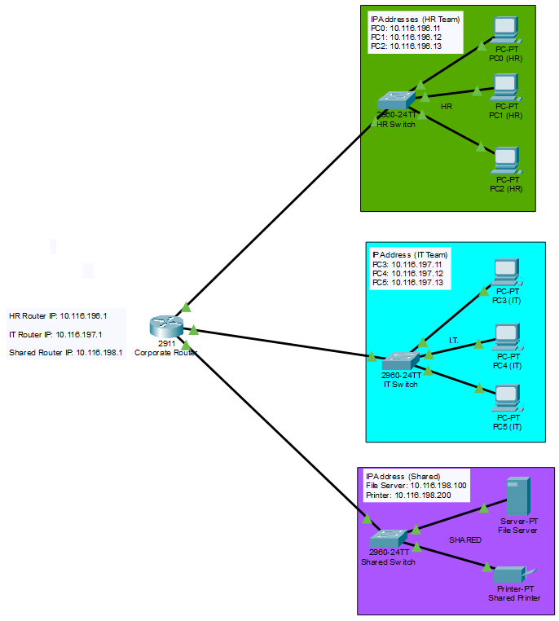Figure 1 – Full network topology

3.2 End-device IP configuration
For each device, open Desktop → IP Configuration (or the equivalent on the server/printer) and capture the static IP, subnet mask and gateway exactly as set.
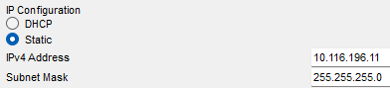
Figure 2 – PC0 (HR) – IP Configuration
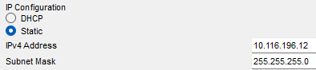
Figure 3 – PC1 (HR) – IP Configuration
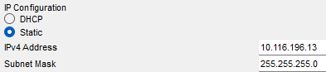
Figure 4 – PC2 (HR) – IP Configuration
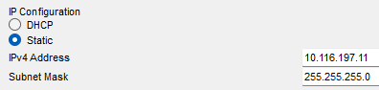
Figure 5 – PC3 (IT) – IP Configuration
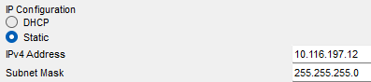
Figure 6 – PC4 (IT) – IP Configuration
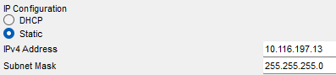
Figure 7 – PC5 (IT) – IP Configuration

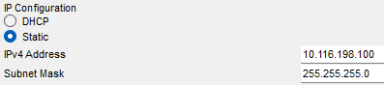
Figure 8 – File Server – IP Configuration
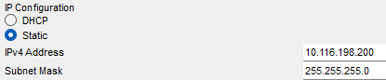
Figure 9 – Network Printer – IP Configuration

3.3 Router interface configuration

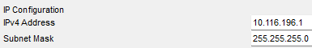

Figure 10 – Router1 – Interface G0/0 (HR – 10.116.196.1)

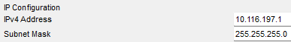

Figure 11 – Router1 – Interface G0/1 (IT – 10.116.197.1)

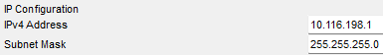

Figure 12 – Router1 – Interface G0/2 (Shared – 10.116.198.1)

3.4 Cabling and link status

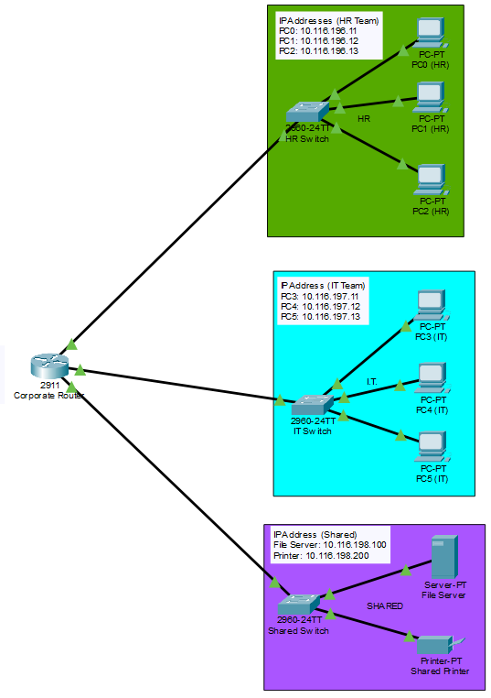

Figure 13 – Link status overview

4. Connectivity Testing

4.1 Cross-department ping (HR → IT)

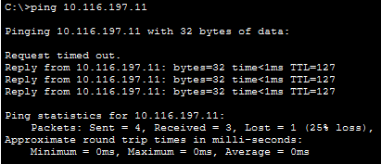

Figure 14 – Ping from an HR PC to an IT PC

4.2 PC to File Server

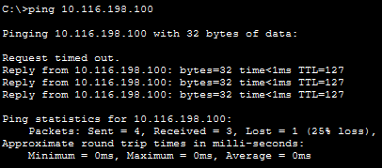

Figure 15 – Ping to the File Server

4.3 PC to Network Printer

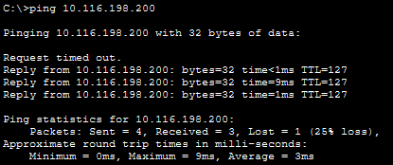

Figure 16 – Ping to the Network Printer

4.4 Realtime / Simple PDU test

Figure 17 – Simple PDU results

5. Results and Reflection

5.1 Summary of results
All required pings were completed successfully. However, each set of four pings had approximately 25% packet loss because one out of the four requests timed out.

5.2 Link to theory
HR (10.116.196.0/24), IT (10.116.197.0/24), and Shared (10.116.198.0/24) are placed on separate subnets to organize the network and separate traffic between the different departments. The router is responsible for allowing communication between these subnets because routers operate at Layer 3 and can forward packets between different IP networks, while switches primarily connect devices within the same local network.

5.3 Errors and limitations
Everything worked correctly during the setup, and there were no major network configuration errors. The only difficulty was finding the Activate button, but I was able to locate it and complete the setup successfully.

5.4 Possible improvements
The network could be improved by using VLANs to further separate HR, IT, and Shared traffic at Layer 2. DHCP reservations could also be used instead of manually configuring static IP addresses, which would make device management easier. Additional network annotations could also be added to make the topology and IP addressing clearer.

References
This lab was adapted in part from resources by Sysnettech Solutions (sysnettechsolutions.com).

